Richmond County 4-H is a youth development program designed to help kids between the ages of 5 and 18 lead positive, productive, and fulfilling lives. Through afterschool programs, clubs, school enrichment, service projects, leadership retreats, and summer programs, 4-H teaches life skills and provides opportunities to succeed and gain new experiences.
At each 4-H event, a pledge that describes each of the 4-Hs is recited. Over the next 4 articles, I will explain the significance of each H and how youth carry out what they mean. The H we will focus on today stands for Hands; “Hands for larger service.” 4-H’ers are busy with their hands all year long, just as the 4-H motto states, “learn by doing.”
4-H’ers are constantly using their hands while learning new things and caring for their projects with hands-on experiences. Some Richmond County youth use their hands to care for animals. Barnyard and Livestock Clubs members raise chickens, livestock, rabbits, house pets, and even reptiles and amphibians for their project. Cooking Clovers members find themselves using their hands to prepare delicious and nutritious meals and snacks. Shooting Sports members use their hands to practice necessary skills to get better and better, focusing on teamwork, precision, dedication, and safety. Our STEAM club, science, technology, engineering, arts, and math, often uses their hands to solder, work with electricity and circuits, build and design model train layouts and robots. Though not limited to these activities, by working with their hands, youth gain life skills such as responsibility, financial management, team work, and motivation.
Another way 4-H’ers use their hands is by giving back to the community. Part of 4-H is teaching youth the importance of serving the community, country and world. Each 4-H Club here in Richmond County contributed in some way to our recent Agricultural Fair by designing booths or educating the public with train layouts, microscopes, and animal exhibits. In addition to educating others at the fair, 4-H members will also be supporting our famers at the Farmers’ Day Parade in Ellerbe. Our Cooking Clovers Club just recently devoted several hours of their time baking delicious desserts for our community Thanksgiving meal. Other service projects conducted by 4-H’ers throughout the year include packing meals for Back Pack Pals, helping Habitat for Humanity, United Way’s partnering agencies, and Place of Grace. At state events, youth often participate in larger scale community service projects such as packing meals that will be distributed all over the world. By giving their hands to larger service, youth improve their self esteem, learn leadership and citizenship skills that will be carried into adulthood, and find the significance of contributing to a group effort.
4-H’ers gain vocational and citizenship skills by giving and working with their hands. However, 4-H is not the only group that can use their hands for larger service. Throughout the year, and this holiday season especially, I encourage your family to practice the meaning behind this “H” and come up with ways you can contribute to our community too. 4-H is currently hosting a gently used toy drive. If you have old toys laying around that are no longer in use, consider bringing them by the office to donate. Perhaps you think money is holding you back from giving, but remember acts of kindness can often be free. You don’t have to buy fancy presents, instead think of opportunities to give your time or talents. 4-H programs are carried out with wonderful volunteers. If you would like to give your time to our youth, ask me about volunteer opportunities; there’s always events to plan, competitions to be judged, and activities to be led. For more information about 4-H events and volunteering opportunities, call me, Catherine Shelley, your 4-H Extension Agent at 910-997-8255.
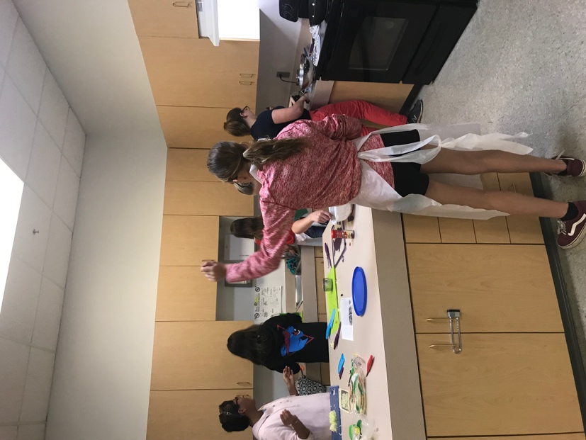
Cooking Clovers Club Members use their hands to prepare a meal.
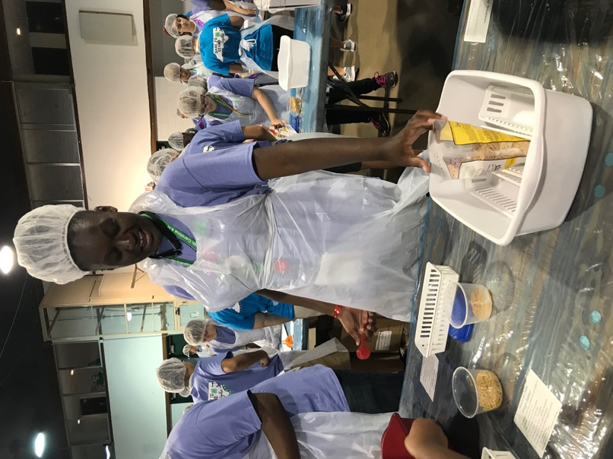
Recent 4-H graduate, Serenity Sturdivant, uses her hands at 4-H Congress to give back to the world by preparing meals that will be sent to over 30 different countries.
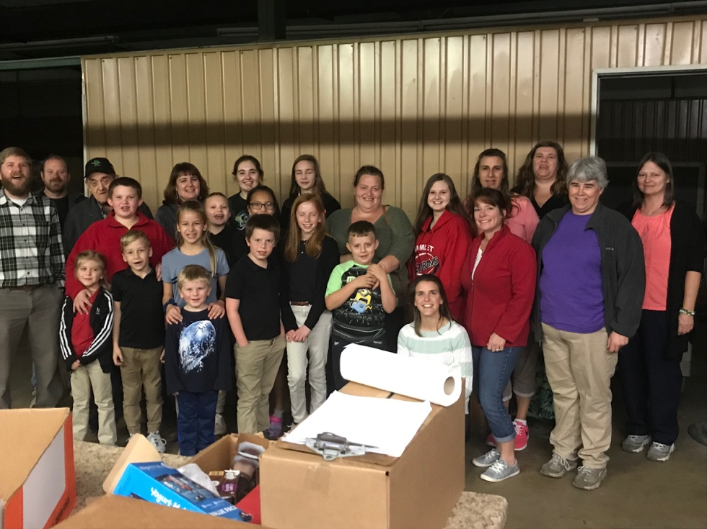
4-H members, parents, and volunteers give their time to pack bags for Back Pack Pals, a wonderful program that helps alleviate childhood hunger here in our county.

