2020 ENROLLMENT
All of 4-H registration will be online this year. Go to
www.4-honline.com
and create or update your account. If you have any questions feel free to give me a call.

February, 2020
Living the Green Life

By: Catherine Shelley
Extension Agent 4-H Youth Development

TEEN RETREAT
REGISTRATION IS DUE
FEBRUARY 14TH
$75.00
EVENT WILL BE MARCH 7-8
MILLSTONE 4-H CAMP

North Carolina Cooperative Extension
Richmond County Center
123 Caroline Street
Rockingham, NC 28379

Phone: 910-997-8255
Fax:1-910-997-8257

4-H Staff Members

Catherine Shelley – 4-H Youth Development Agent

Annie Freeman – COSS Support Staff

WILDFOODS COOKOFF IS TUESDAY, MARCH 24TH FROM 6-8PM.
IF YOU ARE INTERESTED IN COMPETING IN EITHER THE GAME OR NUTS/BERRIES CATEGORIES, PLEASE LET ME KNOW BEFORE MARCH 2ND.

To receive notifications and reminders about 4-H events download this free app and use code 664ghcc2

4-H Competition Teams Interest Meeting will be Tuesday, February 11th from 6-7:00pm, just before the Livestock Club Meeting.
These competitions can have a junior and senior team and will consist of about 4 youth. If you want to see what the competitions consist of, help plan practices, and gain general info, you should attend!
Richmond County teams could include:
WHEP (Wildlife Habitat Education Program)
Poultry judging
Forestry

February Club Meetings
4-H Livestock Club -Tuesday, February 11 Extension Office, 7:00 p.m.
STAY TUNED FOR OTHER CLUB DATES AND LOCATIONS. EARLY VOTING IS HAPPENING AT THE EXTENSION OFFICE. THEREFORE, CLUBS MEETING AFTER THE 12TH WILL HAVE A DIFFERENT LOCATION.

INTERSTED IN RAISING CHICKENS AND PARTICIPATING IN THE 4-H POULTRY SHOW? IT’S NOT TOO LATE TO ORDER BROILERS. BROILER PICKUP IS MARCH 13TH. EACH BROILER IS $2.00
FOR MORE INFORMATION, CALL 417-0258!

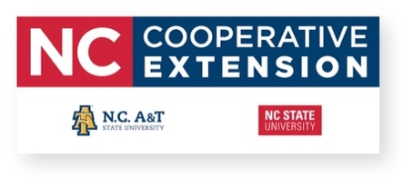
Mark Your Calendar
February 14 Teen Retreat Registration Deadline
February 19 Recordbooks are due
March 7-8 Teen Retreat
March 13-15 Shooting Sports Volunteer Training, Millstone
March 24 Wild Foods Cookoff
March 25 NCSU Day of Giving
April 21 BackPack Pals Service
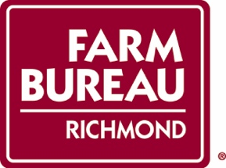
April 25 County Activity Day
May 8 Citizenship Focus Registration Deadline, Poultrybook deadline
May 15 Poultry Show
June 15-17 Citizenship Focus, Raleigh
June 20 We HOST District Activity Day

