October is known for its cooler weather and beautiful leaves but if you ask a 5th grade student in Richmond County Schools about October, they will likely mention a field trip to Millstone 4-H Camp. Each year, fifth graders get an opportunity to learn about science in a hands-on and meaningful way at Richmond County 4-H’s Science Adventures Field Day.
4-H Science Adventures is a week-long event but different schools in the county attend on a different day. This year, 607 students, represented from each elementary school, unloaded the busses for a whole day of learning by doing. The goal of this free, educational opportunity is to allow students to see that what they are learning about in the classroom applies to the real world. Students meet various experts in different fields and begin thinking about future career opportunities, find new interests, and explore several science concepts such as the water cycle, how paper is made, beekeeping, the human body, wildlife, and the significance fire has on various ecosystems.
Throughout the day, students go to seven different science stations led by various community partners. Students also delight in a picnic lunch, a walk around camp, and enjoy being in nature before loading the busses to head back to school for dismissal. This year’s instructors included N.C. Cooperative Extension agents, Soil and Water Conservation, PeeDee National Wildlife Refuge, N.C. Wildlife, N.C. Forest Service, Sandhills Area Land Trust, Richmond County Beekeepers, CYFAR STEM Education, N.C. Climate Office, Jerry Ethridge, and several 4-H volunteers.
This wonderful day is made possible by Richmond County Farm Bureau and United Way. For more information about this field trip or other 4-H activities, please contact Catherine Shelley, 4-H Youth Development Agent at (910) 997-8255.
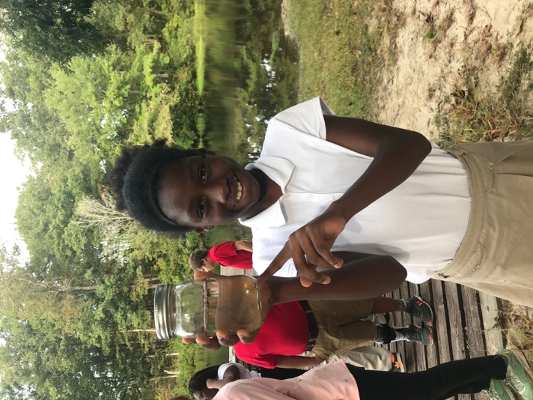
A student from Fairview Heights shows off a dragonfly larva collected from Millstone’s lake. The dragonfly eats mosquito larva and is a good indicator that the freshwater ecosystem is healthy.
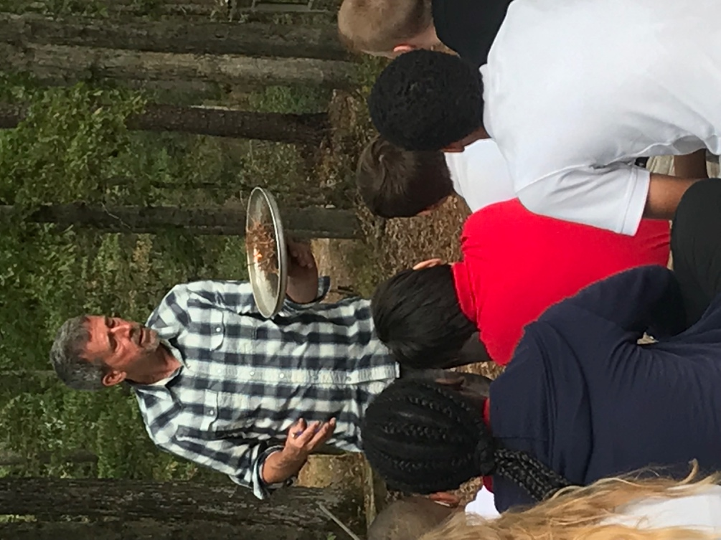
Instructor Jesse Wimberley burns pine straw to show students the importance of fire in a longleaf pine ecosystem.

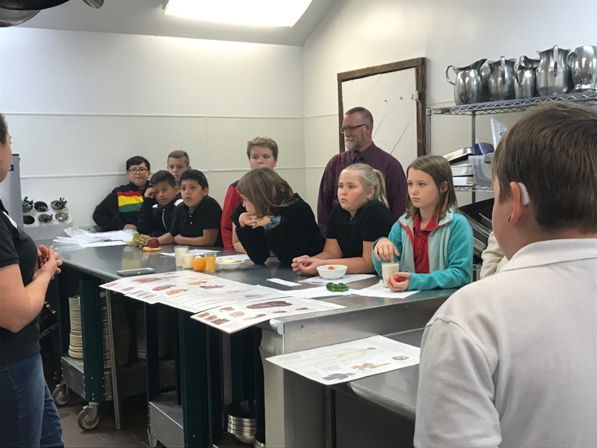
Extension Agent, Janice Roberts teaches about the human body and the importance of nutrition as Mr. Schrinker’s class from West Rockingham looks on. 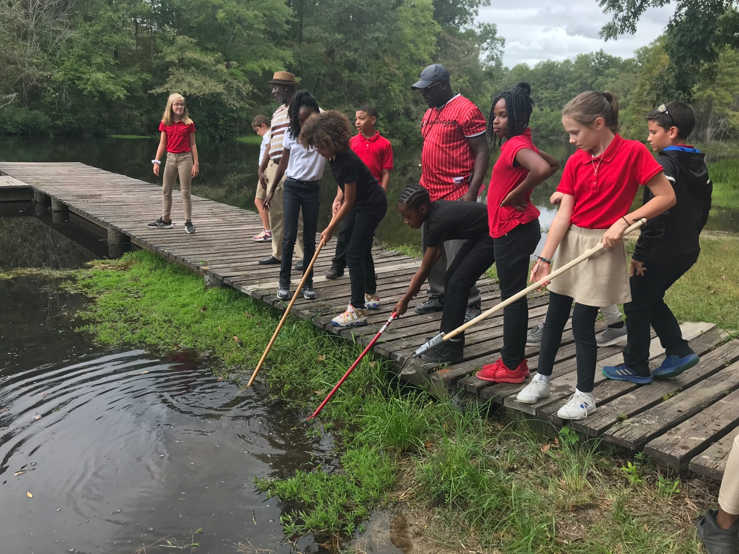Fairview Heights students look for bugs in the water. 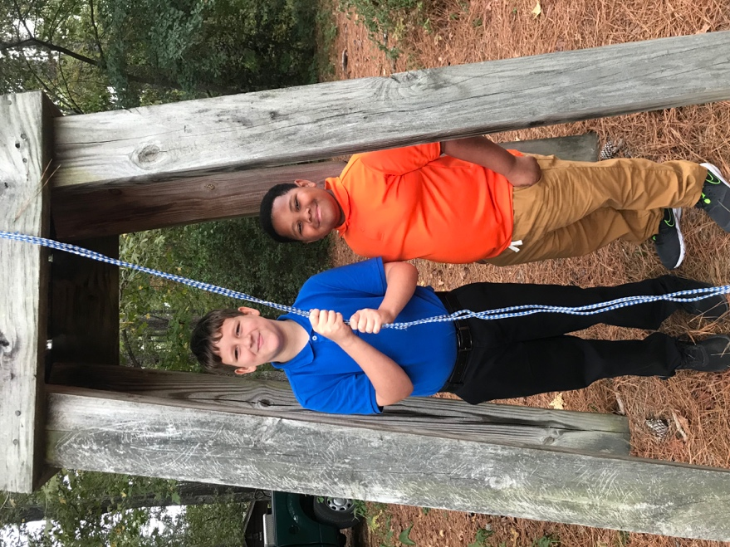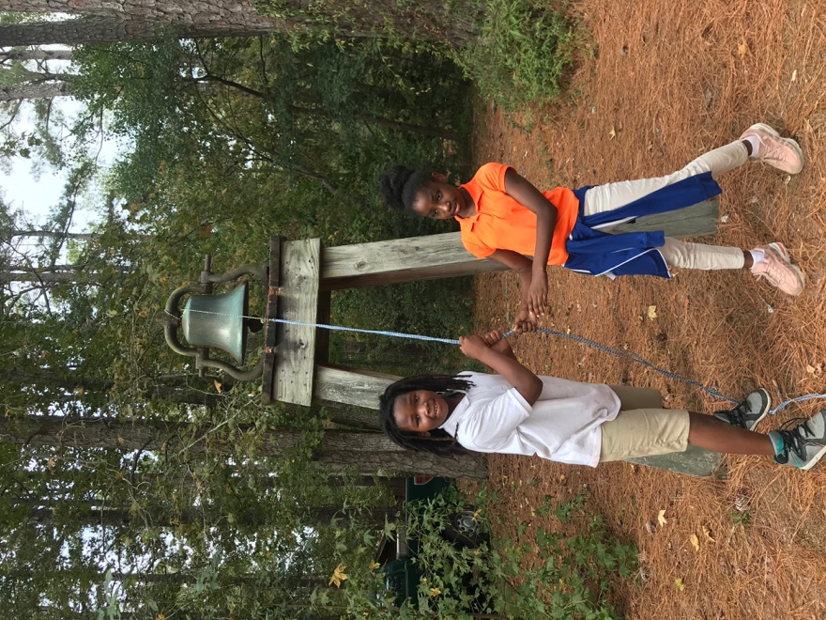
Monroe Avenue students help ring the bell. This is done at the change of each station to notify instructors and Adventurers to move to the next station.
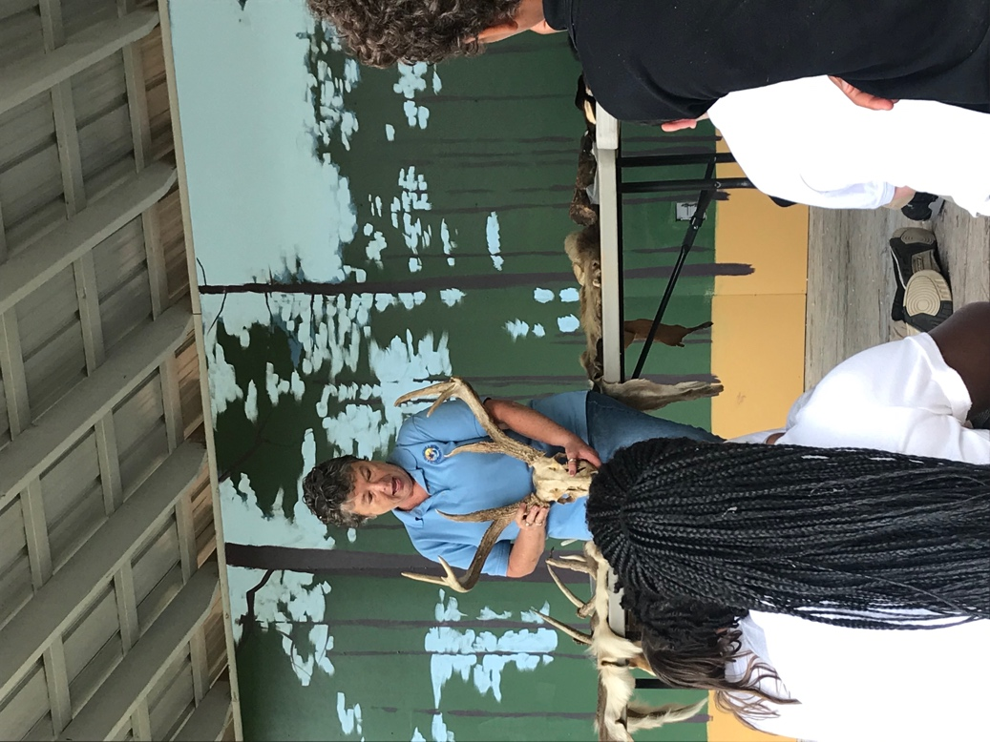
Students learn about various mammals and their role in their ecosystem from PeeDee National Wildlife Refuge.

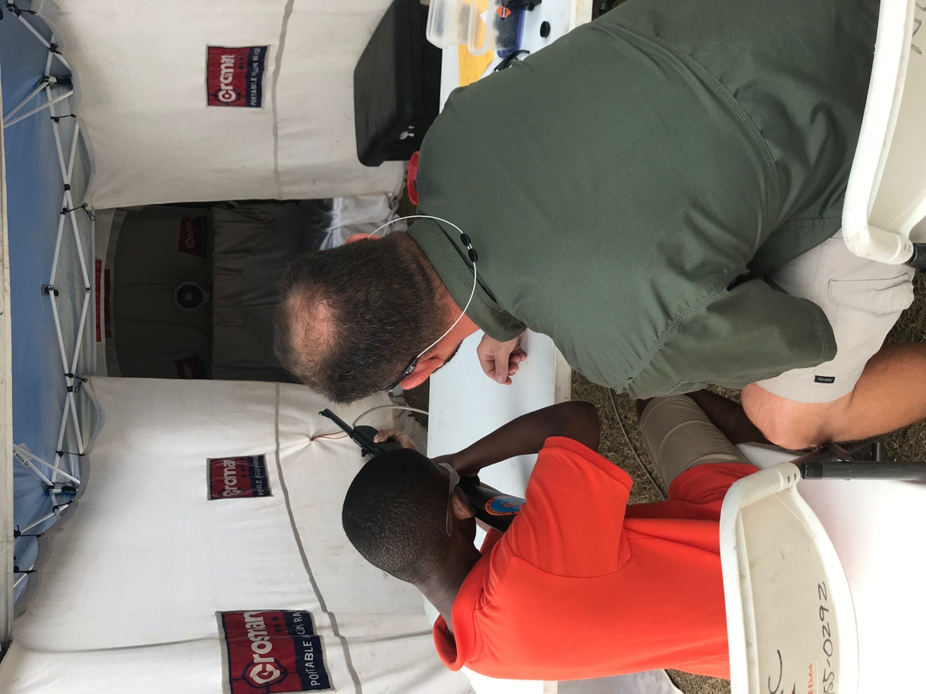
N.C. Wildlife instructor teaches a lesson on air pressure and how it can be used to shoot this air rifle.
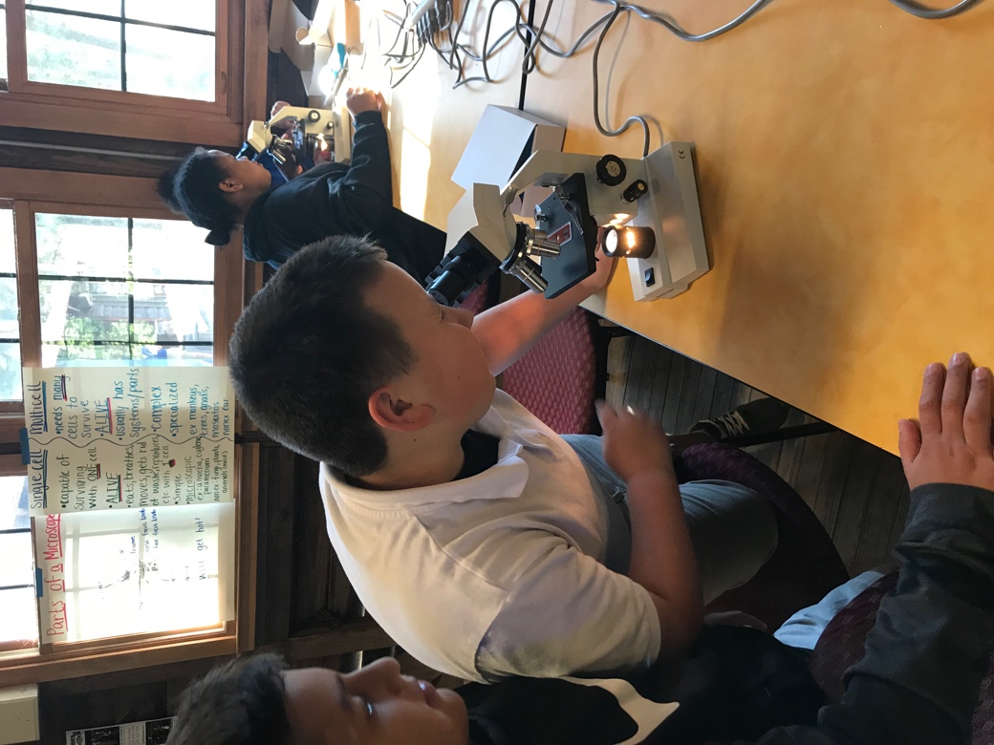
STEM Education coordinator, Katy Haywood, teaches kids the parts of a cell and the differences between single and multi-celled organisms.
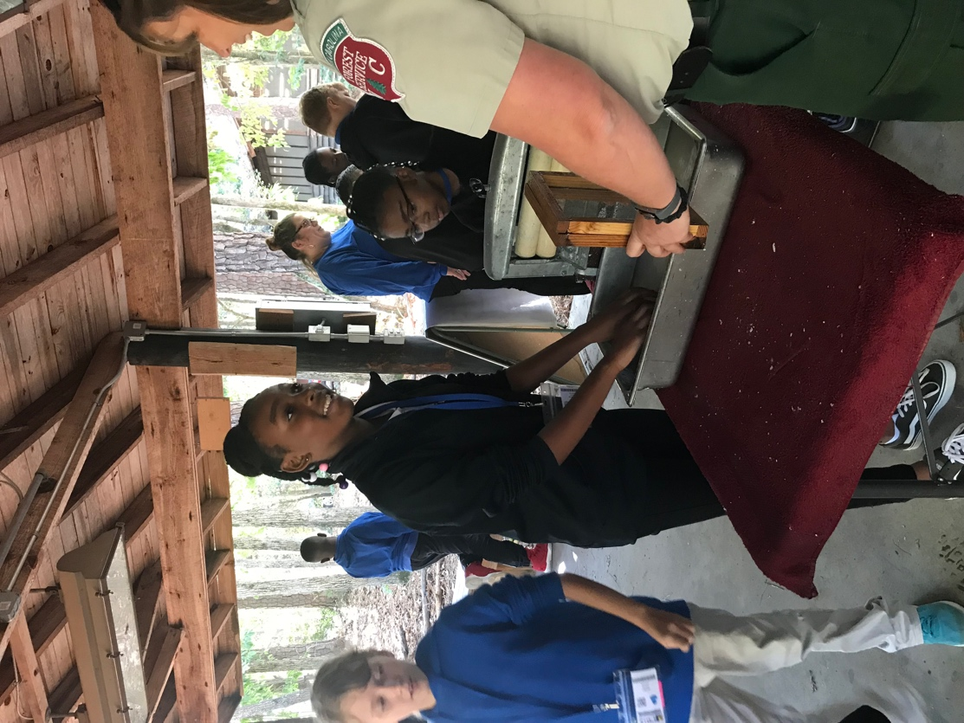
Students from East Rockingham Elementary make paper with the N.C. Forest Service.
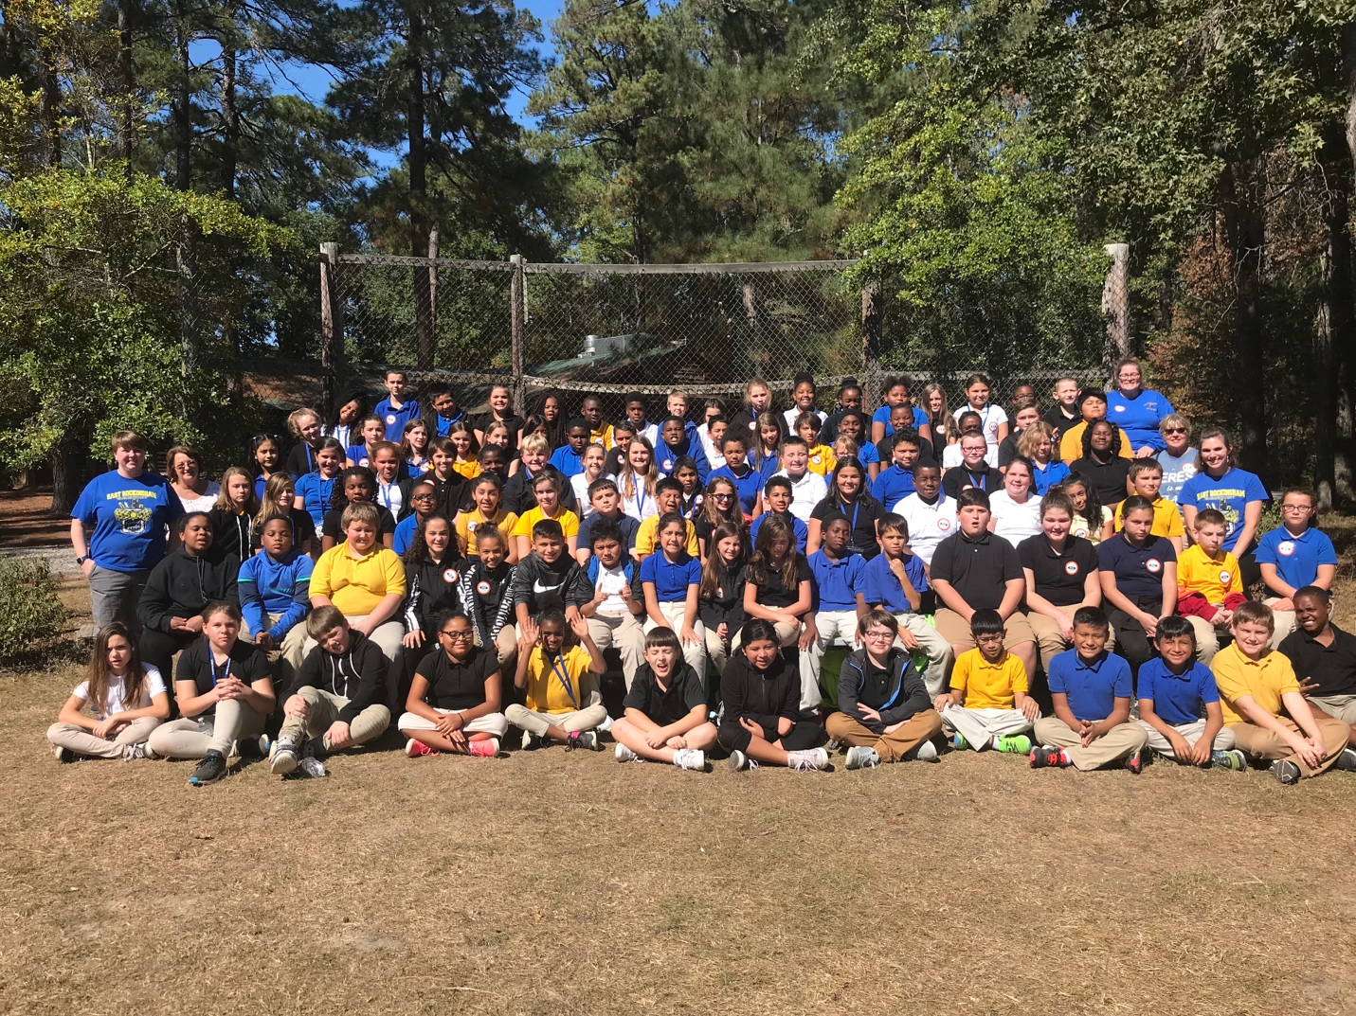East Rockingham Elementary students and staff

